PROFESSIONAL RESUME OF Julia Biley
Administrative Assistant – Mid MN

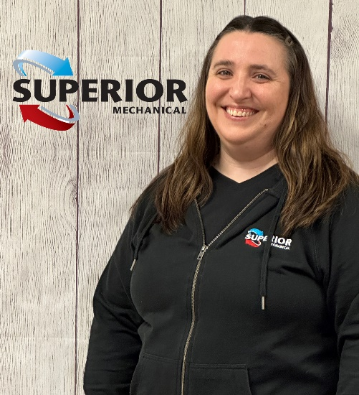
1998 Graduate of Crosby-Ironton High School, Crosby MN
1998-1999 Central Lakes College
1999-2000 Discipleship Training School (Youth With A Mission)
Amsterdam, Netherlands – Graduation Certificate
2000-2004 Target – Department Manager, Baxter MN
2010-2017 Christ Community Church- Administrative, Nisswa MN
2017-2020 Airtech Heating & Cooling - Office Manager, Brainerd MN
2020-2021 Crosslake Veterinary Hospital- Receptionist, Crosslake MN
2021-2023 Aquarius Home Services - Dispatcher, Brainerd MN
2023-Present Superior Mechanical - Administrative, Pequot Lakes MN

CERTIFICATES HELD
2017 – Present Quick Books Certificate (Central Lakes College)

ASSOCIATION INVOLVEMENT
2023 - Present Associated Builders and Contractors ~ Minnesota Chapter
2023 - Present Brainerd Lakes Chamber of Commerce
2023 - Present Builders Association of Minnesota
2023 - Present Mid-Minnesota Builders Association
2023 - Present National Association of Home Builders ~ Minnesota Chapter

REFERENCES:

Ian Misenko, Ferguson Nate Haberman, First Supply
8188 Industrial Park Road 18078 State Highway 371
Baxter, MN 56425 Brainerd, MN 56401
Work: 218-330-3580 Work: 218-829-6910

